Musculoskeletal specialization for sprinting and distance running

Tom Van Wouwe

Jennifer Hicks

Scott Delp

Karen Liu

# Introduction

In elite athletes, human morphology comes in many forms to match the unique and specialized skills required for different sports events. Size, proportions and skeletal geometry can give an edge for specific tasks through advantageous lever arms and inertias. Selecting athletes based on these anthropometric features has been termed *morphological optimization* [1,2]. In addition to differences in skeletal geometry, variation in the gross volume and distribution of muscle and adipose tissue determine athletic performance to a large extent [1,3]. Adapting volume and distribution of muscle can be influenced through *resistance training* [4]. An understanding of these two concepts in relation to specific sport events can, firstly, inform the individualized selection of sports in which to compete, and, secondly, explain how training may shape the muscle distribution to maximize performance.

**This study aims to analyze the effects of skeletal morphology and muscle volume and on sprinting and distance running performance.** The 100m dash is arguably the most prestigious event in track-and-field. Besides, sprinting plays an important role in team-based sports [5,6]. Distance running is one of the most popular sports activity at the recreational level [7]. Particularly the marathon speaks to people’s imagination. The marathon serves as a frontier to investigate the limits of human performance academically [8,9]. Breaking the two hour barrier for the marathon event has inspired two commercial events, Nike sub2 [10] and Ineos 1:59 [11], which generated a lot of attention and exposure of how scientific research contributes to human performance.

**To get more insight into how much skeletal and muscular specialization contribute to sprinting and distance running performance, this paper addresses the following main questions:**

1. How much does skeletal geometry determine sprinting and distance running performance?
2. How much can sprinting and distance running performance be improved by limited, but specific strength training?

**Desirable muscular and skeletal features have been associated with athletic performance extensively by observation and more limitedly by simulation.** In order to relate muscular and skeletal features to performance, researchers have classified athletes according to their somatotype [12,13] (ectomorphic, endomorphic, mesomorphic), measured their segment lengths and circumferences, determined their body composition, or their quantified tissue volumes and characteristics from medical images acquired with different modalities (MRI, CT, …).

**Compared to the general population, sprinters exhibit a more limited height range and a mesomorphic somatotype** [3,14,15] **with strongly developed musculature for both the lower and upper body**. Being very tall or short may be disadvantageous for sprinting as sprinters exhibit a more limited height range compared to the general population [16]. Further, body height appears not to be a major determinant, as it was not associated to performance in 100m personal best times in a group of sprinters [15]. Body proportions might be important for sprint performance. For example, Tomita et al. suggested an increased ratio of tibial-to-femoral leg could be beneficial to reduce the leg’s moment of inertia and thus positive work done by the hip flexors during the swing phase. However, they found that a higher tibial-to-femoral length ratio was associated with better performance in 400m but not in 100m sprinters.

**Increased total muscle volume and muscle volume distribution concentrated in the hip muscles is associated with better sprint performance.** Sprinters score higher on the mesomorphic body type compared to the general population and compared to other athletes**.** In a group of competitive sprinters (100m time: 11.33±0.53 s.) higher calf girth, thigh girth, upper arm girth and BMI were associated with faster 100m personal best times [15]. A recent study comparing elite and sub-elite sprinters found consistently higher hip muscle volumes in the elite group, whereas the plantarflexors showed no differences between the groups [17]. These findings are reflected in the study by Blazevich et al. [18] that confirmed hip strength as an important predictor of sprint performance. With hip flexion and extension suggested as limiter of sprinting performance, a deeper pelvis, increasing the moment arms of hip muscles might be advantageous. However, this has not been substantiated experimentally.

**Compared to the general population distance runners are short, have a low BMI, an endomorphic somatotype** [3,19] **and have a higher tibial-to-femoral length ratio** [20,21]**.** Sedeaud et al. analyzed height, mass and BMI in 100 international male athletes in track events from 100m to the marathon and found that mean height, mean BMI and variability in BMI decrease with increasing length of the running event in which the runners were specialized [22]. In trained endurance runners it was found that higher relative total leg length [21,23] and higher relative tibial length [20] are associated with better distance running performance. Distance runners, when compared to sprinters, were found to have lower normalized by body weight maximal isometric knee flexor and extensor torque [24].

**Musculoskeletal simulation enables to understand whether muscular and skeletal features that associate with performance actually contribute to the performance or are merely a result of another covarying factor.** Observational experiments are limited to infer cause-effect relations. Interventional experiments enable establishing cause and effect for those variables that can be manipulated by an intervention. For example, Deane et al. showed that hip flexor training could significantly improve 40-yd dash times [25]. However, these interventional studies are rare, costly and it is often difficult to control for other, unintended changes induced by the intervention. Musculoskeletal simulation allows decoupling contributions of musculoskeletal geometrical properties and individual muscle properties to task execution and performance.

**Simulation studies to understand the relation between capacity (maximal joint torques or muscle force) and human performance in sprinting [26], jumping [27,28] and gymnastics [29] are abundant but often limited in terms of model complexity [30]. Next, to the best of our understanding no simulation studies exist that investigate how differences in skeletal morphology and consequential musculoskeletal geometry affect performance.** Previous predictive simulation studies that studied for example jumping performance were either torque driven [31] or included only six muscles [28] and were restricted to two dimensions.

**As a part of this study, we developed the first musculoskeletal simulator based on a 33 degrees of freedom skeleton model driven by 92 muscles that is differentiable with respect to both the muscle and skeleton geometrical properties.** Differentiability is enables efficient gradient-based optimization making the simulations done in this paper tractable. The new simulator is an important contribution for future simulation studies that require optimization of both skeleton and muscle parameters to either predict effects of changing such parameters or when solving parameter estimation problems to develop subject-specific models based on experimental data.

# Results

**We performed predictive simulations of sprinting and marathon running using five different musculoskeletal models to understand the effects of skeletal morphology and strength training in sprinters and distance runners (**Figure 1**).** The first model is the generic Hamner model (GEN) [32], representing an average male. **The second and third model are models with optimized skeletal dimensions for sprinting (SPRINT_SKEL) and marathon running (MARATHON_SKEL).** For SPRINT_SKEL and MARATHON_SKEL, muscle volume of each muscle was scaled linearly by the relative increase in total skeletal volume. Muscle optimal fiber length and tendon slack length were scaled linearly with the relative length change of the muscle tendon unit length in the anatomic pose while maintaining the relative positions for the muscle insertion points and the geometries for muscle wrapping. **To mimic strength training, the fourth and fifth model were adaptations GEN with 5% total muscle volume added; the skeleton dimension were kept the same.** The distribution of this added muscle volume was optimized for sprinting (MUSC_SPR) and marathon running (MUSC_MAR). Developing SPRINT_SKEL, MARATHON_SKEL, MUSC_SPR, MUSC_MAR was solved as a predictive simulation problem where the appropriate parameters were optimized to maximize sprinting (maximal average velocity across one gait cycle) and distance running (minimal energy consumption across a marathon at 3.33m/s) performance. Next we performed predictive simulations of sprinting and marathon running with all five models, resulting in ten simulations, to analyze the performance for both tasks for every model. In the next paragraphs we will assess how these optimized models compare to GEN in terms of parameters and performance on both sprinting and distance running.

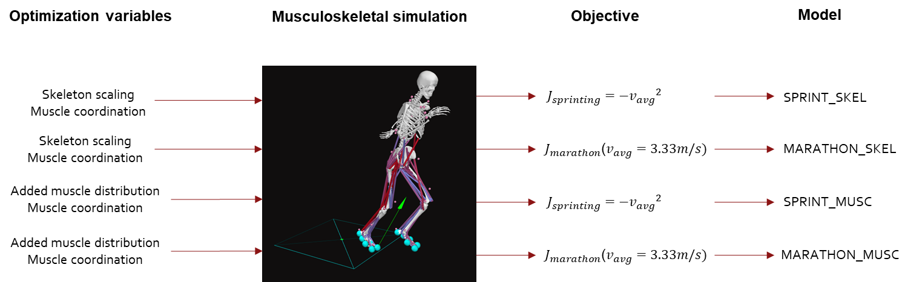

Figure - Generation of the 4 new skeletal models is solved as on optimization problem where different parameters (describing the scaling of the skeleton or distribution of some added muscle volume) are optimized together with muscle coordination in order to maximize sprinting or marathon running performance.

A specialized skeletal morphology improves sprinting performance by 13% and marathon running economy by 36%

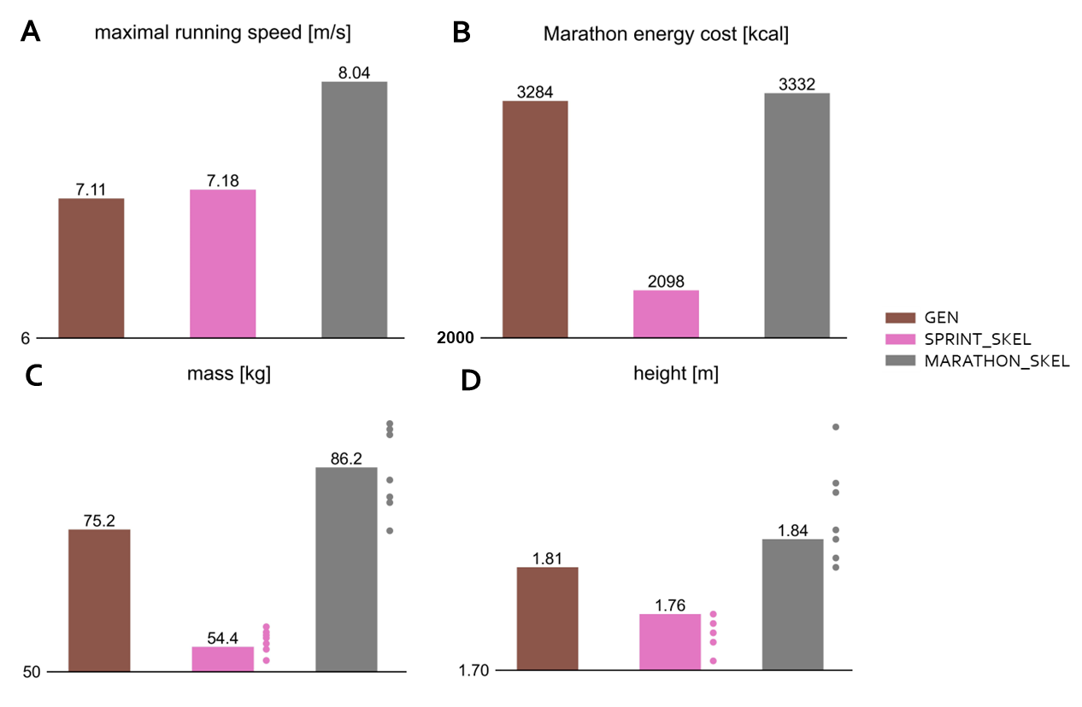

Figure - Effect of optimized skeleton morphology on sprinting and marathon performance. Dots for the mass and height plots show the results for the all-time top ten sprinters and marathon runners.

**The predicted maximal sprinting speed for SPRINT_SKEL (8.04m/s) was 13% higher compared to GEN (7.11m/s), while MARATHON_SKEL was only slightly better in sprinting (7.18m/s) (**Figure 2 **- A).** **The energy cost to cover a marathon at 3.33m/s was 36% lower in MARATHON_SKEL (2098 kcal) compared to GEN (3284 kcal) (**Figure 2 **- B). SPRINT_SKEL had a slightly higher energetic marathon cost (3332 kcal) compared to GEN (**Figure 2 **– B).** **SPRINT_SKEL (86.2kg, 1.84m) is taller and heavier, whereas MARATHON_SKEL (54.4kg, 1.76m) is shorter and lighter compared to GEN (75.2kg, 1.81m) (**Figure 2 **– C,D).** Predictions for both mass and height fell within the range of values found in the top ten fastest all-time marathon runners for MARATHON_SKEL and top ten fastest all-time 100m sprinters for SPRINT_SKEL **(**Figure 2 **– C,D)**. The low maximal sprinting speeds of our simulations compared to world class sprinters (>11m/s) can be explained by the relative weakness of the muscles in the used models. For example, when doubling the maximal isometric force of all muscles in GEN by 1,5 and 2, as is done several previous sprinting simulation studies [33], the maximal running speed increased to 8.39m/s and 10.66m/s, which is much closer to the fastest ever recorded speed of 12.42m/s. The speed of 3.33m/s was chosen as a representative speed for a marathon for the model as it has a similar ratio to elite marathon running speed as the maximal running speed of GEN compared to elite sprinting speed.

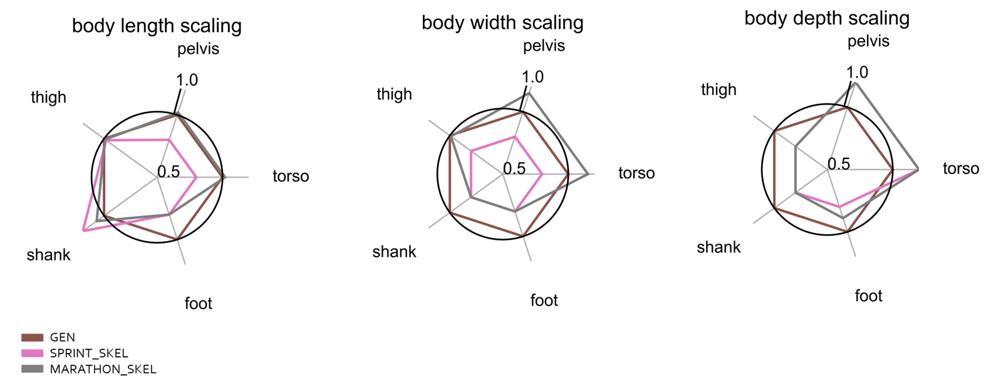

Figure - Relative changes of skeleton segments with respect to GEN in SPRINT_SKEL and MARATHON_SKEL.

**The increased mass in SPRINT_SKEL is mainly due to a wider and deeper torso and pelvis, while the size of the thigh, shank and foot segments were reduced in all dimensions with the length of the shank as exception (**Figure 3**). In MARATHON_SKEL the reduction in mass was mainly the result of reduced segment size in all three dimensions compared to GEN for most segments with a longer shank and deeper pelvis and torso as exceptions (**Figure 3**).** Being light is beneficial for marathon runners for two reasons. First, it reduces overall inertia and thus required mechanical work to run. Next, lower muscle volume, which was modelled proportional to mass, linearly decreases the maintenance and activation heat rate contributions to metabolic energy consumption. The increased mass of SPRINT_SKEL, increases muscle volume and thus force capacity, which allows to generate high muscle forces in order to accelerate the body segments.

**Both SPRINT_SKEL and MARATHON_SKEL have reduced leg inertia, which reduces the force and energy required during swing (**Figure 3**). Nevertheless, longer tibia were beneficial for both sprinting (SPRINT_SKEL +8%) and distance running (MARATHON_SKEL +20%), whereas femoral lengths remained unchanged in SPRINT_SKEL and MARATHON_SKEL compared to GEN (**Figure 3**).**

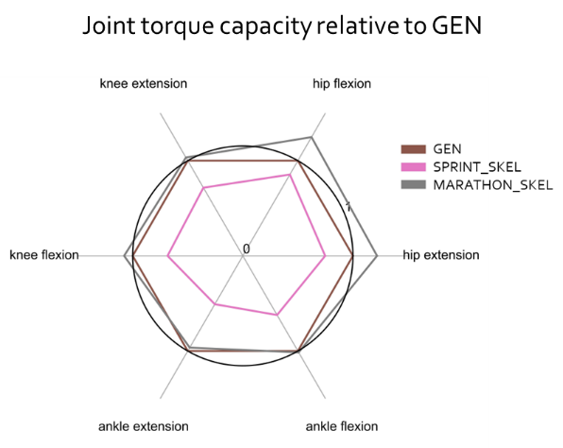

Figure - Relative joint torque capacity of SPRINT_SKEL and MARATHON_SKEL compared to GEN.

**Analysis at the joint torque level reveals that the capacity of the hip muscles is important for both sprinting and distance running (**Figure 4**). The increased pelvis and torso depth in both SPRINT_SKEL and MARATHON_SKEL, increase the moment arms of the hip flexors and extensors (Figure 3).** Hip flexion and hip extension capacity is higher in SPRINT_SKEL compared to GEN because of higher moment arms and higher maximal muscle force. Despite much weaker muscles in MARATHON_SKEL (reductions between 25% and 45%), the hip flexion and extension capacity is maintained to about 80%. Despite the stronger muscles, capacity for knee flexion/extension and ankle flexion/extension was not improved by a lot in SPRINT_SKEL. MARATHON_SKEL had strongly reduced capacities for knee flexion/extension and ankle flexion/extension.

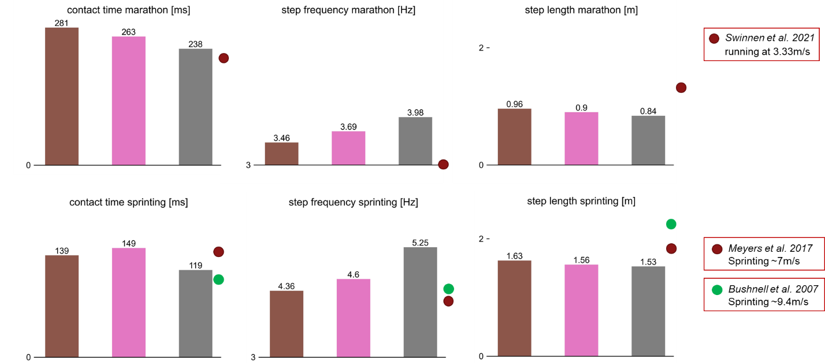

Figure - Contact time, step frequency and step length during marathon running and sprinting for GEN, SPRINT_SKEL and MARATHON_SKEL.

**Changes in spatiotemporal measures during sprinting and distance running show that SPRINT_SKEL improved sprinting performance over GEN by reducing contact time by 43ms, increasing step frequency by 0.52Hz and shortening step length by 0.12m whereas MARATHON_SKEL improved running economy at marathon speed by a slightly longer contact time (+10ms), higher step frequency (0.24Hz) and shorter step length (0.07m) (**Figure 5**).** Despite a longer total leg length compared to GEN, step length decreases in both SPRINT_SKEL and MARATHON_SKEL during both sprinting and marathon running. The ability to operate at higher step frequencies is likely enabled by the reduce inertia of the leg. The predicted contact times of our simulations are close to experimental values found by Swinnen et al. [34] for running at 3.33 m/s and by Meyers et al. [35] and Bushnell et al. [36] for sprinting at 7m/s and 9.4m/s respectively **(**Figure 5**)**. Predicted step frequencies are higher with predicted step lengths being lower compared to experimental observations.

Training the hip muscles is beneficial for better sprinting, strength training is not very effective for distance runners

**Given a limited time budget to do strength training, what muscle groups would one need to focus to improve sprinting and distance running performance?** We addressed this question by providing our optimization framework a muscle volume budget of 5% of the total muscle volume of the generic model with the limitation that a specific muscle volume could only ‘grow’ by a maximum of 20% of its original volume. We optimized this distribution of muscle volume for maximizing sprinting performance (SPRINT_MUSC) and minimizing energetic cost of running a marathon (MARATHON_MUSC).

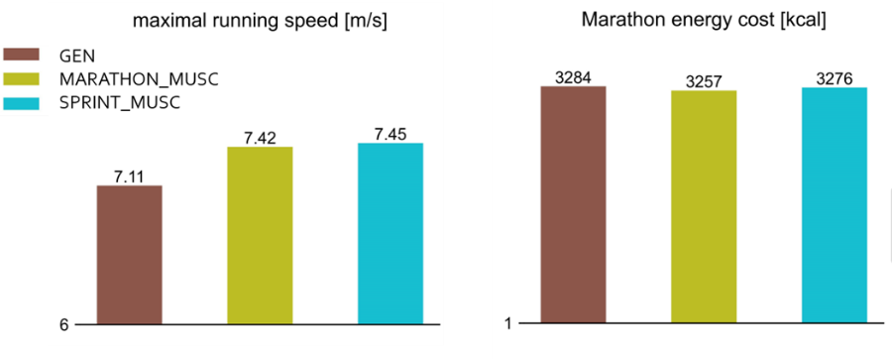

Figure - Effect of optimized muscle training (5% total added muscle volume) on sprinting and marathon performance.

**SPRINT_MUSC realized a 4.5% higher maximal running speed (7.45 m/s) compared to GEN (7.11 m/s), while MARATHON_MUSC reduced the energetic cost of running a marathon by only 0.8% compared to GEN (**Figure 6**).** It thus seems that strength training is much more valuable for sprinters than it is to distance runners. This aligns with the findings of optimizing the skeleton dimension that mainly showed that marathon performance could be improved by decreasing the mass (and strength) of the body, while sprinting performance was mainly improved by increasing joint torque capacity by increasing strength, especially for the hip joint.

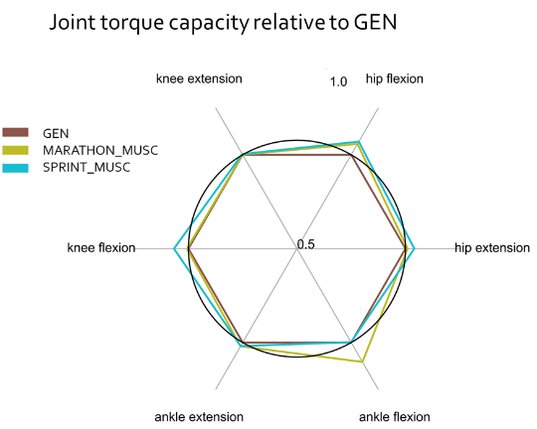

Figure -- Relative joint torque capacity of SPRINT_MUSC and MARATHON_MUSC compared to GEN.

**By the specialized distribution of the added muscle volume SPRINT_MUSC increased joint torque capacity mostly for hip flexion, hip extension and knee flexion and to a lesser extent of ankle extension (**Figure 7**).** From the hip flexors those muscles were targeted that also assist in abduction and adduction and/or have larger moment arms (iliacus, adductor longis, psoas and tensor fascia latae) (Figure 8 – hip flexion). For the hip extensors those muscles were target that have a biarticular function in generating knee flexion (longhead biceps femoris and semimembranosus) (Figure 8 – hip extension, knee flexion). For the plantarflexors those muscles were targeted that were biarticular (gastrocnemius) and have a larger plantarflexor moment arm (flexor hallucis, flexor digitorum, tibialis posterior) (Figure 8 – ankle plantarflexion).

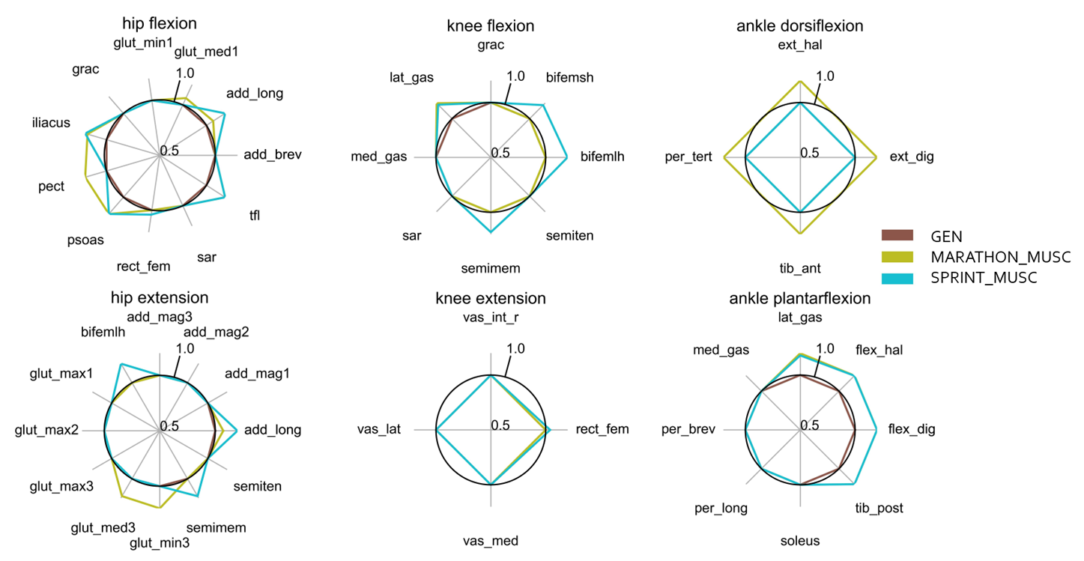

Figure - Muscle capacity for MARATHON_MUSC and SPRINT_MUSC compared to GEN.

**MARATHON_MUSC showed increased joint torque capacity for hip flexion and ankle extension/flexion.** The hip extension and ankle plantarflexion adaptations are similar in MARATHON_MUSC and SPRINT_MUSC, while the increase in muscle strength for the hip extension occurs mainly in the uniarticular hip extensors (gluteus minimus and gluteus medius) without targeting knee flexion.

# Methods

Differentiable musculoskeletal simulator

The state $\left(x\right)$ of a musculoskeletal model is determined by the activations $\left(a\right)$ of the 92 included muscles, the fiber lengths of these muscles $\left(l_{m}\right)$, the generalized positions $\left(q\right)$ and velocities $\left(\dot{q}\right)$ that include the six degrees-of-freedom of the pelvis and 33 joint angles:

$$x= \left[a ;l_{m} ;q ;\dot{q}\right]$$

The state derivatives are described by muscle activation dynamics :

$$\dot{a}= f_{act}\left(e,a\right),$$

muscle-tendon dynamics, which also determine tendon force:

$$\left[{\dot{l}}_{m}, F_{t}\right]=f_{mt}\left(a,l_{mt}(q,p_{s}),{\dot{l}}_{mt}(q,\dot{q},p_{s}),p_{m}(p_{s})\right),$$

and skeleton dynamics:

$$\ddot{q}=f_{s}\left(q,\dot{q},F_{t},p_{s}\right)={M\left(q,p_{s}\right)}^{-1}\left[G\left(q,p_{s}\right)+C\left(q,\dot{q},p_{s}\right)+τ\left(F_{t},q,\dot{q},p_{s}\right)\right],$$

with $e$ muscle excitations, $F_{t}$ tendon forces, $l_{mt}$ muscle-tendon lengths, ${\dot{l}}_{mt}$ muscle-tendon velocities, $p_{s}$ the skeleton parameters, $p_{m}$ the muscle parameters, $τ$ joint torques, $M$ the mass matrix, $G$ the vector of gravitational forces, $C$ the vector of Coriolis and centrifugal forces. We collect these equations into the system dynamics:

$$\dot{x}= f_{dyn}\left(e,x,p_{s}\right)=\left[f_{act} ;f_{mt} ;f_{s}\right].$$

The joint torques are the result of the biological joint torques generated by the muscles $(τ_{m})$ and joint torques that result from contact $(τ_{c})$:

$$τ=τ_{m}+τ_{c},$$

$$τ_{m}=R\left(q,p_{s}\right)*F_{t},$$

$$τ_{c}=f_{c}\left(q,\dot{q},p_{s}\right),$$

with the 92x33 matrix of moment arms of the muscles with respect to the joints and $f_{c}$ the function describing the joint torques that result from contact. Contact is modelled using eight Hunt-Crossley contact spheres attached to the feet and the ground. The location and properties of these contact spheres are as in [ref].

The skeleton parameters $p_{s}∈R^{3N_{b}}$ consist of three scaling factors for each body that scales that body in the three dimensions. As such the skeleton parameters change segmental geometrical and inertial properties and thus $M, G, C, f_{c}$.

The computation of the muscle tendon lengths and the moment arm matrix is implemented as a neural network that takes the relative joint positions and skeleton parameters as input. OpenSim performs two non-differentiable operations to compute muscle tendon lengths and moment arms. The first step is to scale the musculoskeletal geometry. The second step is the actual computation which is an iterative, computationally costly and non-differentiable operation. We replaced this two step process by a neural network:

$$\left[ l_{mt},R\right]=f_{l_{mt},R}\left(q,p_{s}\right).$$

The muscle tendon velocities are computed by applying the chain rule:

$${\dot{l}}_{mt}=\frac{∂l_{mt}}{∂q}∙\dot{q}.$$

Finally the Hill-type muscle parameters consist of maximal isometric force, tendon slack length, optimal fiber length, pennation angle and tendon stiffness [37]. When scaling the skeleton, the tendon slack length and optimal fiber length are adapted as well depending on the total length change of the muscle tendon unit length when the model is place in the anatomical pose $(q=0)$**:**

$$l_{m,opt,p_{s}}=l_{m,opt}*\frac{f_{l_{mt},R}\left(0,p_{s}\right)}{f_{l_{mt},R}\left(0,1\right)}.$$

Skeleton dynamics are derived from SimBody using an adapted version of the differentiable implementation by Falisse et al. [38]. The adaptation is needed to allow for differentiation with respect to $p_{s}$.

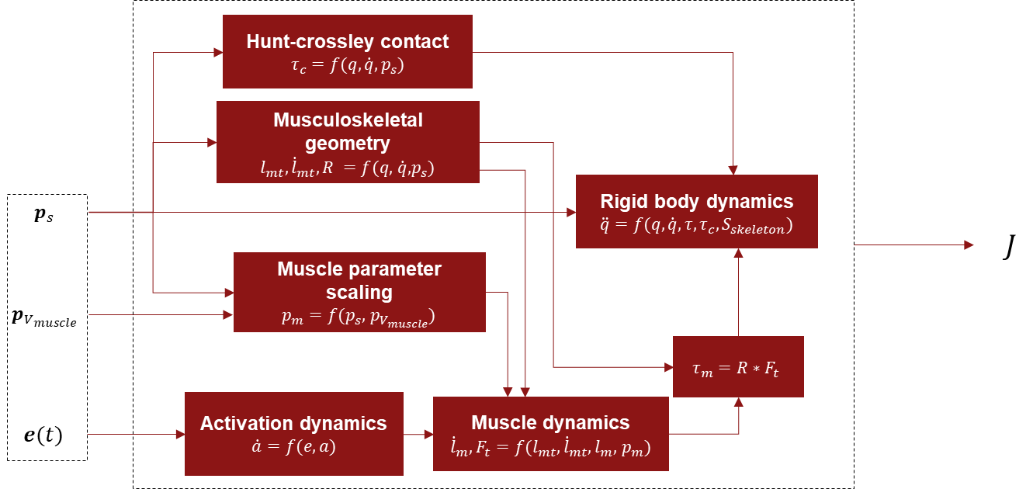

Figure - Differentiable musculoskeletal simulator

Trajectory optimization

1. Hawes MR, Sovak D. Morphological prototypes, assessment and change in elite athletes. J Sports Sci. 1994;12: 235–242. doi:10.1080/02640419408732168

2. Norton K, Olds T, Olive S, Craig N. Anthropometry and sports performance. Antrhopometrica. 1996; 287–364.

3. Sharma SS, Dixit NK. Somatotype of athletes and their performance. Int J Sports Med. 1985;6: 161–162. doi:10.1055/S-2008-1025831/BIB

4. Krzysztofik M, Wilk M, Wojdała G, Gołaś A. Maximizing Muscle Hypertrophy: A Systematic Review of Advanced Resistance Training Techniques and Methods. Int J Environ Res Public Health. 2019;16. doi:10.3390/IJERPH16244897

5. Di Salvo V, Baron R, Tschan H, Calderon Montero FJ, Bachl N, Pigozzi F. Performance characteristics according to playing position in elite soccer. Int J Sports Med. 2007;28: 222–227. doi:10.1055/S-2006-924294/ID/35

6. Faude O, Koch T, Meyer T. Straight sprinting is the most frequent action in goal situations in professional football. https://doi.org/101080/026404142012665940. 2012;30: 625–631. doi:10.1080/02640414.2012.665940

7. Scheerder J, Breedveld K, Borgers J. Running across Europe: The Rise and Size of one of the Largest Sport Markets - Google Books. 2015. Available: https://books.google.com/books?hl=en&lr=&id=LLaYBgAAQBAJ&oi=fnd&pg=PP1&ots=CCj4qxwHOC&sig=BM8-REuCFsGmoKG6BWazt1ZKiaY#v=onepage&q&f=false

8. Hoogkamer W, Kram R, Arellano CJ. How Biomechanical Improvements in Running Economy Could Break the 2-hour Marathon Barrier. Sport Med. 2017;47: 1739–1750. doi:10.1007/S40279-017-0708-0/FIGURES/9

9. Joyner MJ, Ruiz JR, Lucia A. The two-hour marathon: who and when? J Appl Physiol. 2011;110: 275–277. doi:10.1152/japplphysiol.00563.2010

10. Breaking2. Nike GB. [cited 31 Oct 2022]. Available: https://www.nike.com/gb/running/breaking2

11. INEOS 1:59 Challenge. [cited 31 Oct 2022]. Available: https://www.ineos159challenge.com/

12. Atlas of men, a guide for somatotyping the adult male at all ages. - PsycNET. [cited 21 Oct 2022]. Available: https://psycnet.apa.org/record/1955-01908-000

13. Heath BH, Carter JEL. A modified somatotype method. Am J Phys Anthropol. 1967;27: 57–74. doi:10.1002/AJPA.1330270108

14. Carter J. The somatotypes of athletes--a review. undefined. 1970.

15. Barbieri D, Zaccagni L, Babić V, Rakovac M, Mišigoj-Duraković M, Gualdi-Russo E. Body composition and size in sprint athletes. J Sports Med Phys Fitness. 2017;57: 1142–1146. doi:10.23736/S0022-4707.17.06925-0

16. Uth N. Anthropometric Comparison of World-Class Sprinters and Normal Populations. J Sports Sci Med. 2005;4: 608. Available: /pmc/articles/PMC3899678/

17. Miller R, Balshaw TG, Massey GJ, Maeo S, Lanza MB, Johnston M, et al. The Muscle Morphology of Elite Sprint Running. Med Sci Sports Exerc. 2021;53: 804–815. doi:10.1249/MSS.0000000000002522

18. Blazevich AJ. Predicting Sprint Running Times From Isokinetic and Squat Lift Tests: A Regression Analysis. J Strength Cond Res. 1998 [cited 21 Oct 2022]. Available: https://www.academia.edu/29201982/Predicting_Sprint_Running_Times_From_Isokinetic_and_Squat_Lift_Tests_A_Regression_Analysis

19. Muñoz CS, Muros JJ, Belmonte ÓL, Zabala M. Anthropometric Characteristics, Body Composition and Somatotype of Elite Male Young Runners. Int J Environ Res Public Heal 2020, Vol 17, Page 674. 2020;17: 674. doi:10.3390/IJERPH17020674

20. Laumets R, Viigipuu K, Mooses K, Mäestu J, Purge P, Pehme A, et al. Lower Leg Length is Associated with Running Economy in High Level Caucasian Distance Runners. J Hum Kinet. 2017;56: 229. doi:10.1515/HUKIN-2017-0040

21. Ueno H, Suga T, Takao K, Miyake Y, Terada M, Nagano A, et al. The potential relationship between leg bone length and running performance in well-trained endurance runners. J Hum Kinet. 2019;70: 165–172. doi:10.2478/HUKIN-2019-0039

22. Sedeaud A, Marc A, Marck A, Dor F, Schipman J, Dorsey M, et al. BMI, a Performance Parameter for Speed Improvement. PLoS One. 2014;9: e90183. doi:10.1371/JOURNAL.PONE.0090183

23. Mooses M, Mooses K, Haile DW, Durussel J, Kaasik P, Pitsiladis YP. Dissociation between running economy and running performance in elite Kenyan distance runners. J Sports Sci. 2015;33: 136–144. doi:10.1080/02640414.2014.926384

24. AN EVALUATION OF HAMSTRING/QUADRICEP STRENGTH RATIOS IN ELITE LONG DISTANCE RUNNERS AND SPRINTERS L Davimes and I Levinrad. doi:10.10520/AJA10155163_990

25. Deane RS, Chow JW, Tillman MD, Fournier KA. Effects of hip flexor training on sprint, shuttle run, and vertical jump performance. J strength Cond Res. 2005;19: 615–621. doi:10.1519/14974.1

26. Lee SSM, Piazza SJ. Built for speed: musculoskeletal structure and sprinting ability. J Exp Biol. 2009;212: 3700–3707. doi:10.1242/JEB.031096

27. Wilson C, Yeadon MR, King MA. Considerations that affect optimised simulation in a running jump for height. J Biomech. 2007;40: 3155–3161. doi:10.1016/j.jbiomech.2007.03.030

28. Bobbert MF, Van Zandwijk JP. Sensitivity of vertical jumping performance to changes in muscle stimulation onset times: a simulation study. Biol Cybern 1999 812. 1999;81: 101–108. doi:10.1007/S004220050547

29. King MA, Kong PW, Yeadon MR. Maximising forward somersault rotation in springboard diving. J Biomech. 2019;85: 157–163. doi:10.1016/J.JBIOMECH.2019.01.033

30. McErlain-Naylor SA, King MA, Felton PJ. A Review of Forward-Dynamics Simulation Models for Predicting Optimal Technique in Maximal Effort Sporting Movements. Appl Sci 2021, Vol 11, Page 1450. 2021;11: 1450. doi:10.3390/APP11041450

31. Wilson C, Yeadon MR, King MA. Considerations that affect optimised simulation in a running jump for height. J Biomech. 2007;40: 3155–3161. doi:10.1016/J.JBIOMECH.2007.03.030

32. Hamner SR, Seth A, Delp SL. Muscle contributions to propulsion and support during running. J Biomech. 2010;43: 2709–2716. doi:10.1016/J.JBIOMECH.2010.06.025

33. Haralabidis N, Serrancolí G, Colyer S, Bezodis I, Salo A, Cazzola D. Three-dimensional data-tracking simulations of sprinting using a direct collocation optimal control approach. PeerJ. 2021;9: e10975. doi:10.7717/peerj.10975

34. Swinnen W, Mylle I, Hoogkamer W, DE Groote F, Vanwanseele B. Changing Stride Frequency Alters Average Joint Power and Power Distributions during Ground Contact and Leg Swing in Running. Med Sci Sports Exerc. 2021;53: 1–21. doi:10.1249/MSS.0000000000002692

35. Meyers RW, Oliver JL, Hughes MG, Lloyd RS, Cronin JB. Asymmetry During Maximal Sprint Performance in 11- to 16-Year-Old Boys. Pediatr Exerc Sci. 2017;29: 94–102. doi:10.1123/PES.2016-0018

36. Bushnell TD, Analysis AB. A Biomechanical Analysis of Sprinters vs. Distance Runners at Equal and Maximal Speeds. 2004;217. Available: https://scholarsarchive.byu.edu/etd/217

37. Groote F De, Kinney AL, Rao A V, Fregly BJ. Evaluation of Direct Collocation Optimal Control Problem Formulations for Solving the Muscle Redundancy Problem. Ann Biomed Eng. 2016;44: 2922–2936. doi:10.1007/s10439-016-1591-9

38. Falisse A, Serrancolí G, Dembia CL, Gillis J, Groote F De. Algorithmic differentiation improves the computational efficiency of OpenSim-based trajectory optimization of human movement. Srinivasan M, editor. PLoS One. 2019;14: e0217730. doi:10.1371/journal.pone.0217730